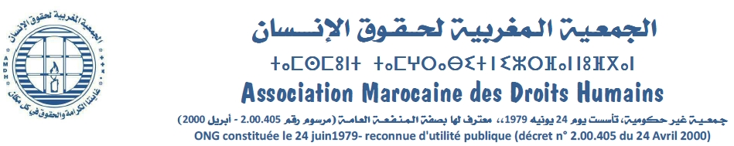
Khadija Ryadi
The MAHR candidate for the position of FIDH Vice-President at the 40th Congress held in Taipei, Taiwan from 21 to 26 October 2019

Khadija Ryadi is a human rights defender and activist since 1983, winner of the prestigious United Nations Prize of Human Rights Prize for 2013 "for her work for various causes, including against impunity, for equality between men and women, self-determination and freedom expression, regardless of sexual orientation."
She was president of the Moroccan Association of Human Rights. A former coordinator of the Moroccan Collective of Human rights Instances (22 Moroccan NGOs). Since 2015, she has been coordinating the Maghreb Coordination of Human Rights Organizations comprising 26 NGOs from six countries. In addition, she a member of the International Committee of the World Women's March. Currently, she is the coordinator of MAHR's international relations committee.
The Moroccan Association of Human Rights
www.amdh.org.ma

The MAHR was founded on 24 June 1979. Currently, it has more than 12,000 members, spread over 97 sections throughout different cities and regions of Morocco (including three sections in Europe). The international human rights declarations, covenants and conventions constitute the unique referential of its action. The association defends human rights in their universality and globality.
The MAHR coordinates a network of Moroccan human rights NGOs composed of 22 associations and a Maghreb network of 26 NGOs operating in 6 countries. Additionally, the association plays an important role in the various thematic networks and groups engaged in defending human rights in their diversity, such as the Moroccan coalition for the abolition of the death penalty as well as the network for the right to work in partner with other NGOs and unions.
In addition, the MAHR is a fieldwork association, through concrete actions to support, for example, migrants in the most remote areas where they are victims of discrimination and violence. Through its network of lawyers, it also defends prisoners of conscience before courts, and it acts in different socio-professional circles to disseminate human rights values. More than 50,000 direct beneficiaries have benefited from the association's training workshops since 2006, for which it received the African Human Rights Defenders Award in 2015. The MAHR is actually the biggest human rights NGO in Morocco and its work is often reflected in the independent press.
The MAHR is presenting its candidature for the position of Vice-President of FIDH, to contribute to the efforts of this network, and of all its member leagues, to defend and promote rights and freedoms in the world.
The MAHR will act, in particular, so that FIDH can:
- Implement strategies able to reduce risks threatening global and regional human rights, resulting in particular, from the rise of extremism and populism that that fuel violence, including against human rights defenders, and reinforce the discrimination and injustice.
- Contribute to making operational the new commitments of the states, such as the United Nations Declaration on the Rights of Peasants and Other People Working in Rural Areas, the UN General Assembly declaration proclaiming the period 2019-2028 "Nelson Mandela Decade of Peace", the Resolution 1325 and following on the role of women in building peace and the efforts made for a legally binding international instrument to regulate the activities of transnational corporations
This would require advocacy actions at the international level. However, actions at the local level is also important. It would require better mobilization of rural residents, women and young people to defend human rights. Thus, the MAHR could contribute with its experience in the field of human rights action with the various socio-professional categories, in the mobilization of women and young people for the defence of human rights, in the local and regional networking, particularly for social, cultural, environmental and economic rights.
The MAHR will also act for the adoption of new approaches for a better place for women in the struggle for peace and for a better and fairer world without violence or discrimination. This, in turn, require combining the issues of gender, ecology and peace-building especially in the MENA region and Africa.

