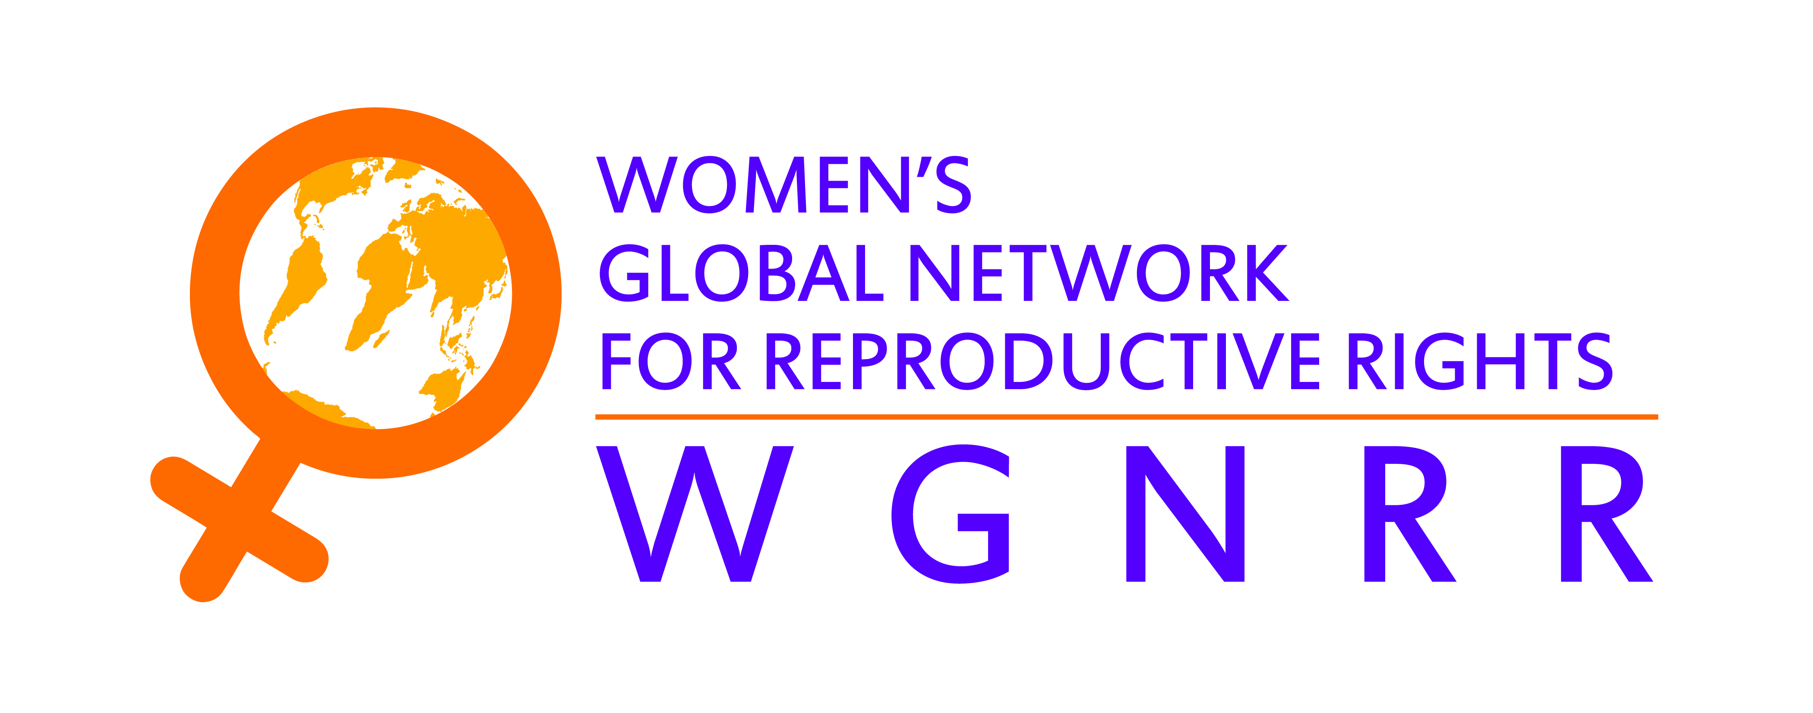
Coordination Office:
Barangay Central Diliman
3 Marunong Street
1100 Quezon City
T: + 63 632 92877858
F: + 63 632 928-7992 local 108

His ExcellencyJakayaMrishoKikwete
President of Tanzania
The State House
Magogoni Road
PO Box 9120
Dar es Salaam
Tanzania
RE: Arrest of sixteen human rights defenders following peaceful protest over government failure to resolve health crisis
His Excellency,
I am writing to express concern about the arrest of sixteen human rights defenders Dr Helen Kijo Kisimba, Executive Director of the Legal and Human Rights Centre (LHRC); Ms Anaelia Nkya, Executive Director of the Tanzania Media Women's Association (TAMWA); Mr Irenei Kiria, Executive Director of the youth organisation SIKIKA; Ms Anna Migila and Messrs Marcus Albany and Godfrey Mpandikizi, all LHRC staff members; and Erin Riley, from the Canadian Bar Association. Amongst those arrested were also five members of the Tanzania Gender Network, members of the Tanzania Gender Networking Programme(TGNP)as well as members of the Network for Disabled People Living with HIV/AIDS (NEDPHA).
On 9 February 2012, at approximately noon, the sixteen human rights defenders were arrested by the police after arriving to the Muhimbili National Hospital (MNH) in Dar es Salaam. They went to the hospital to await the outcome of talks between the Prime Minister and health workers who had been on strike for several weeks. They have been arbitrarily detained in the Oyster Bay Police Station since 9th January and they have been released on bail.
Women’s Global Network for Reproductive Rights (WGNRR) is gravely concerned for the physical and psychological integrity of those activists considering that they may face inhuman and degrading acts in police station; expresses its concern over the deteriorating state of sexual and reproductive health rights of thousands Tanzanian during this health crisis in Tanzania; and calls on the police to respect the right of all Tanzanians to freedom of expression, association and assembly.
We deplore the arrests of the activists by Tanzania authorities and believe that these human rights defenders have been targeted solely as a result of their legitimate human rights work, in particular their work to advance human rights including sexual and reproductive health rights of all Tanzanians. Human rights are guaranteed by the Tanzania constitution, policies and laws as well as by international human rights treaties which Tanzania has committed to.

Women’s Global Network for Reproductive Rights urges the authorities in Tanzania to:
- Immediately and unconditionally release the sixteen human rights defenders, as their arrest goes counter to their human rights such as freedom of expression, association and assembly fully guaranteed by the Tanzanian constitution.
- Drop all charges immediately against the sixteen human rights defenders, as we believe that they are accused solely as a result of their legitimate human rights work;
- End systematic harassment and intimidation of human rights defenders by government officials; and
- Guarantee in all circumstances that all human rights defenders in Tanzania are able to carry out their legitimate human rights activities without fear of reprisals and free of all restrictions including judicial harassment.

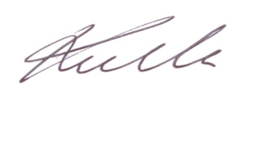
Yours sincerely,

Kathy Mulville
Executive Director - WGNRR

Copy furnished:

The Right Hon. Mizengo K. Peter Pinda
Prime Minister of the United Republic of Tanzania
P.O. Box 3021
Dar es Salaam
Tanzania

Inspector SaidiMwema
General Inspection of Police Force
Ghana/Ohio Street
P.O. Box 9141 Dar es Salaam
Tanzania

